**Header image**

A picture containing insect, animal

Description generated with very high confidence

**Quote:** *The first step towards change is awareness. The second step is acceptance.*

**General text:**

Close the gap between solution and result with our 3-day course in Change management.

Change ACT has partnered with the South African firm and Change, PROSCI® primary affiliate, to bring a revolutionary change management solution to the Mauritian market.

High quality training materials **l** Cutting-edge e-toolkit access **l** Manage resistance **l** Increase ROI **l** Treat employees right **l** Become certified in change management **l** Book your seats NOW

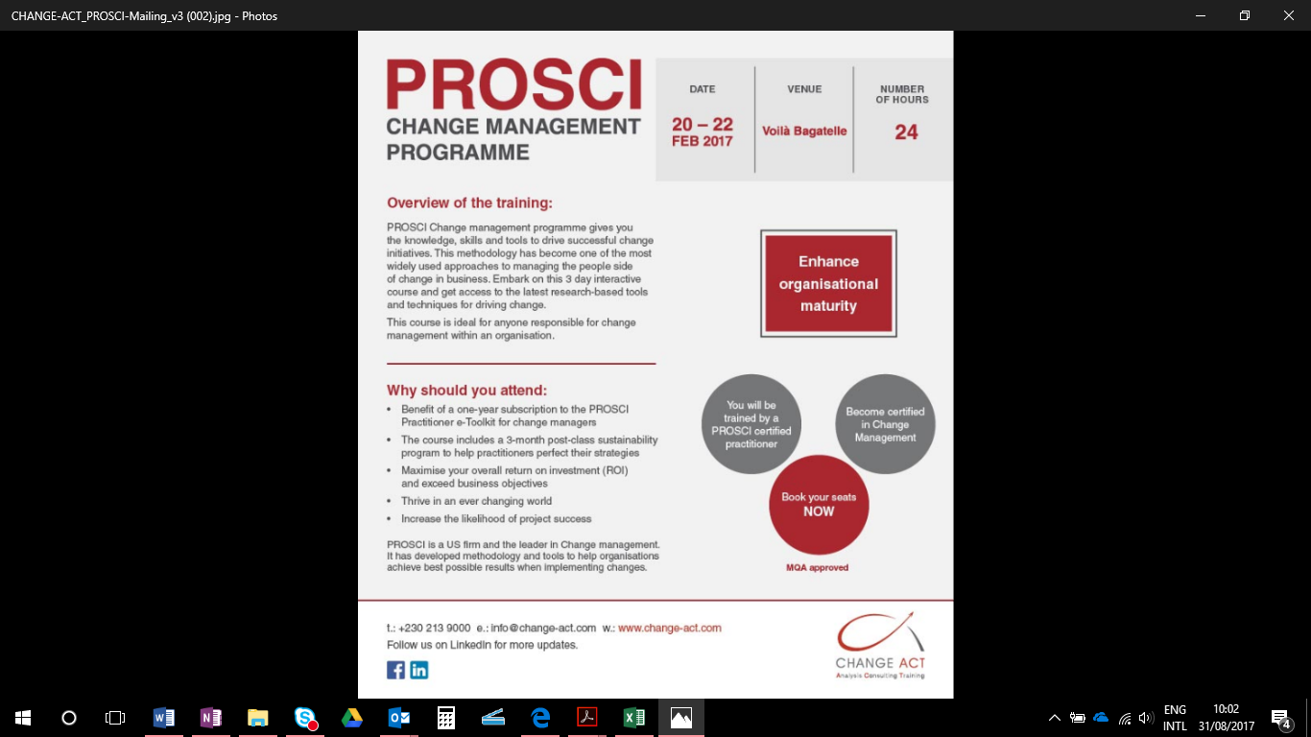**Pertinent Information we wish to communicate**

|  |  |
| --- | --- |
| Save the date | 25 - 27 Oct 2017  24 Hours |
| Resource person | Quentin Orsmond  Certified PROSCI change management Trainer |
| MQA approved | HRDC refundable |

**Others**

Follow us on our LinkedIn page for regular updates

*PROSCI is the world's leading change management research organisation.*